Roll-Offs

The following information describes how PSP pricing works for roll-offs and explains the current pricing calculation.

1.
Vendor Pricing QuickBase
2.
Mysql Database
3.
Hub app: Pricing Tool
4.
Sales Management ZTER’s QuickBase

- Records from the Vendor Pricing app in QuickBase are saved into the MySQL database.
There are two ways to keep the records updated:
- Vendor Pricing app in QuickBase: When a new Roll-off is added, or a record is edited or deleted, a webhook is triggered to update the corresponding record in the MySQL database.
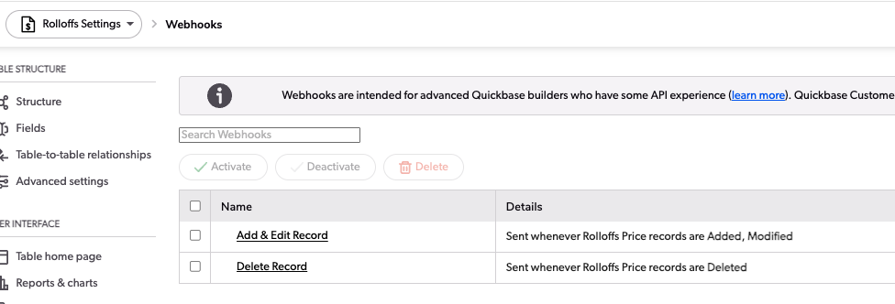
- Hub app: The other way to sync all records is to click the 'Sync' button in Pricing > Settings. This option is only visible to users who belong to the 'ZTERS.VendorManagement' group. This option syncs records for Toilets, Roll-offs, Containers, and Pricing Zones.
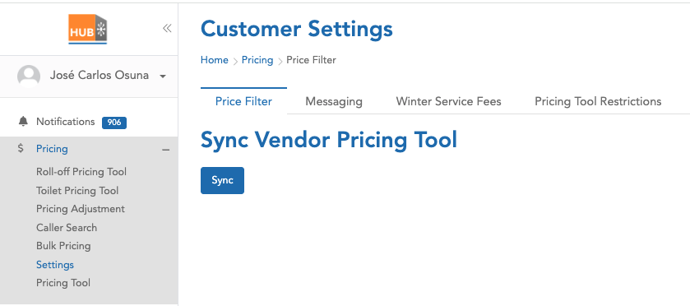
- MySQL database.
The following are the fields saved in the MySQL database, along with their respective sources:

MySQL Field | Vendor Pricing QuickBase | FID
rid | Record ID# | 3
3 | Record ID# | 3
13 | Product Type | 13
21 | Related Pricing Zone | 21
23 | Company Name | 23
24 | Preferred Vendor | 24
26 | Hauler - Sales RID | 26
28 | Zone Type | 28
34 | Zip List | 34
36 | Standard Charge | 36
37 | Delivery Charge | 37
39 | Rental Charge | 39
43 | Ton Rate | 43
59 | Standard Charge +$140 (Suggested) | 59
117 | Standard Charge +$140 (Suggested) for 3-15 | 117
60 | Suggested Delivery Charge 35% | 60
61 | Days Allowed (Suggested) | 61
62 | Suggested Rental Charge 35% | 62
63 | Delivery Rate Per | 63
65 | Tons Included (Suggested) | 65
115 | Tons Included (Suggested) for 3-15 | 115
66 | Suggested Ton Rate 35% | 66
118 | Suggested Ton Rate 35% #2 | 118
69 | Debris | 69
70 | Pricing Zone - Address Miles | 70
71 | Pricing Zone - Depot Address | 71
75 | Pricing Zone - Depot Address: Postal Code | 75
76 | Pricing Zone - Radius Miles | 76
81 | Pricing Zone - Zip List - Zip Based | 81
87 | Pricing Zone - DNU | 87
88 | DNU | 88
89 | DNU - Zone or Individual | 89
91 | Total Customer Charge +$140 (Suggested) | 91

- Hub app > Pricing Tool.
By applying filters such as Zip code and address, the Pricing tool in the Hub app shows records or suggestions based on the data stored in our database, originally imported from QuickBase.
The following are the columns shown for Roll-Offs:
Column | MySQL Field
Provider Name | 23
Size | 13
Debris | 69
Delivery | 60
Charge | 117
Days | 61
Rental Rate | 62
Tons | 115
Ton Rate | 118

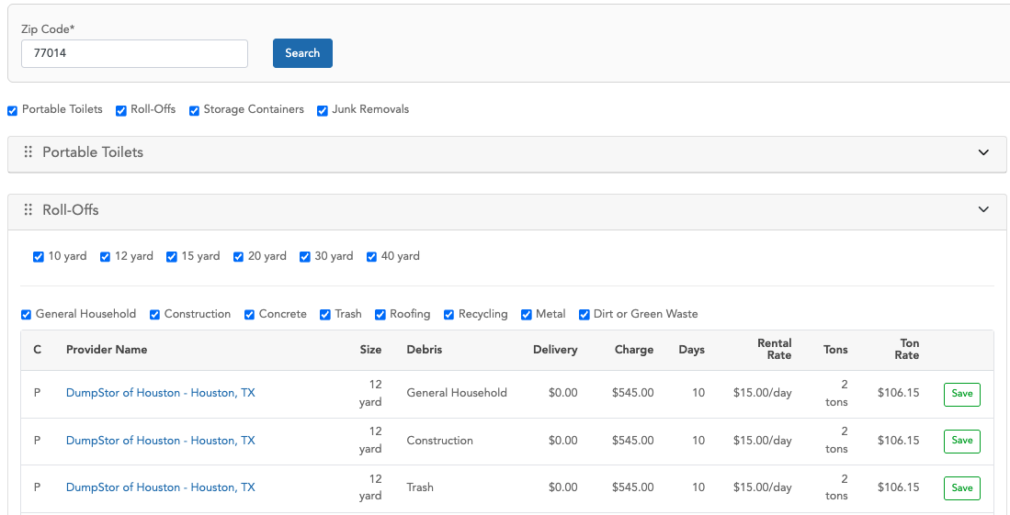

The value shown in the 'Charge' column is, in some cases, different from the one saved in MySQL because a process applies certain pricing adjustments. These adjustments are designed to increase or decrease the final amount in that column and can be applied selectively to specific record IDs.

Pricing adjustments process:
- Try to find in “pricingadjustment” table a record filtering by:
- Active
- Product: ‘all’ or ‘dumpster’’
- is_applicable: ‘%Hub Pricing Tool%’
If there are no records in the previous table, no pricing adjustments are applied.
- The second step is to try to apply additional filters to the records retrieved from step 1:
- Check the expiration logic: if the 'is_expire' flag is set to '1' and the 'expire_date' is greater than or equal to the current date, or if the 'is_expire' flag is '0', the record continues processing.
- The second filter logic checks the value of the 'geography' column: records with the value 'all', or where the zip code is included in the list, are allowed to continue processing.
- The third step is to sort the records by priority and apply only the record with the highest priority.
Also, in a hierarchical manner, check whether it is necessary to apply the adjustment for specific PSPs:
- This applies if the record is of type 'some PSPs' or 'some confirmed prices', and the 'dumster_id' column is not empty. If so, verify whether the suggestion record is included in the IDs stored in the 'dumster_id' column.
- If the previous conditions are false, check whether the record type is 'all' or 'all PSPs', or if the product has a value of 'all'.
- The final record from the 'pricingadjustment' table determines the amount to be increased or decreased. This adjustment can be applied to all records shown as suggestions, or to a specific record ID, depending on the value of the 'type' column (e.g., 'some PSPs' or 'some confirmed prices').
  - If the “price_flag” column has a value of “1”, the value in the “amounts” column is directly considered as the amount to increase or decrease from the final total.
  - If the “price_flag” column has a value of “0”, the system takes the value from the “percentage” column, divides it by 100, and multiplies the result by the original value from “customer_standard_charge”. This calculated value is then used to increase or decrease the final total.
  - To determine whether the adjustment is an addition or a subtraction, the system uses the value in the “price” column, which indicates either increase or decrease.

- When the user clicks the Save button, a “Roll-off” is created in the Sales Management ZTERs app in QuickBase.
As part of preparing the information needed to create the record, the system performs a query directly to the Rolloffs entity in the Vendor Pricing app in QuickBase, rather than retrieving the data from our local database. It then uses the retrieved information to attempt to create the new record.

The new roll-off record is created based on the following information:
Sales Management ZTER’s QuickBase | FID | Vendor Pricing QuickBase FID | Rounded?
Debris | 18 | 69
Size | 32 | 13
Quantity | 59 | 1
Status | 20 | “Quote in Progress’
Related Product Type | 441 | According to the size, the possible values for Product Type ID are:  10 yard => 73  12 yard => 74  15 yard => 75  18 yard => 76  20 yard => 77  25 yard => 78  30 yard => 79  35 yard => 80  default value 81
Product Type | 442 | It is the same case as in the row above
Site ID | 25 | Parameters from the request
PT Delivery Rate | 545 | 60 | Yes
Delivery Charge (Customer) | 14 | 60 | Yes
PT Rental Rate | 546 | 62 | Yes
Rental Charge (Customer) | 13 | 62 | Yes
PT Disposal Rate | 547 | 118 | Yes
Ton Rate (Customer) | 54 | 118 | Yes
Tons Included (Customer) | 33 | 115
Automatic Pull | 511 | 35
Standard Charge (Hauler) | 10 | 36
Delivery Charge (Hauler) | 9 | 37
Rental Charge (Hauler) | 8 | 39
Rental Type | 463 | 40
Rental Period Days | 464 | 55
Rental Rate Per Day | 776 | 56
Disposal Type (Hauler) | 453 | 41
Tons Included (Hauler) | 34 | 42
Ton Rate (Hauler) | 46 | 43
Standard Ton Rate Cutoff | 455 | 57
Conditional Ton Rate | 454 | 58
Fuel Environ Percent (Hauler) | 11 | 44
Fuel Environ Dollars (Hauler) | 12 | 45
% Tax (Hauler) | 97 | 46
Tax $ (Hauler) | 172 | 47
Other Charge (Hauler) | 95 | 48
Other Description (Hauler Rate) | 469 | 49
Other Billing Frequency (Hauler Rate) | 470 | 50
Dry Run (Hauler) | 472 | 51
Relocation (Hauler) | 474 | 52
Vendor Pricing RID | 742 | 3
Hauler ID | 35 | 26
Standard Charge (Customer) | 15 | 117 | Yes
PT Standard Rate | 544 | 117 | Yes
Days Allowed (Hauler) | 50 | 112
Pricing Tool | 542 | 24
Pricing Tool - Zone RID | 772 | 21
Pricing Tool - Experiment (Test) | 960 | 119
Pricing Tool - Experiment (Control) | 961 | 120
Pricing Tool - Vendor List | 771 | 26 (If FID 24 == 1)

As part of the new record, a note is added with specific information such as Hauler ID, Hauler Name, Size, Debris, Charge, Days Included, Rental Rate, Ton Rate, Tons, and Delivery Charge. For the charge-related fields, both the original value and the rounded price are included.

Example:
Hub app: Pricing Tool
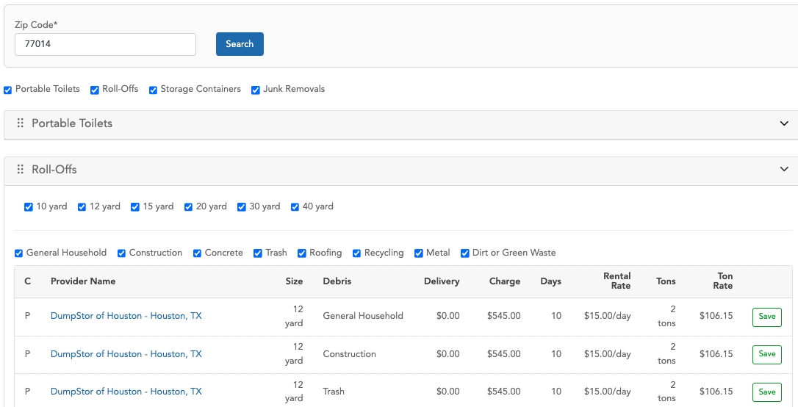
The following record was created using the first suggestion from the table, after clicking the Save button
https://zters.quickbase.com/nav/app/bhwfnx4uw/table/bhwgt8xdv/action/dr?rid=919241
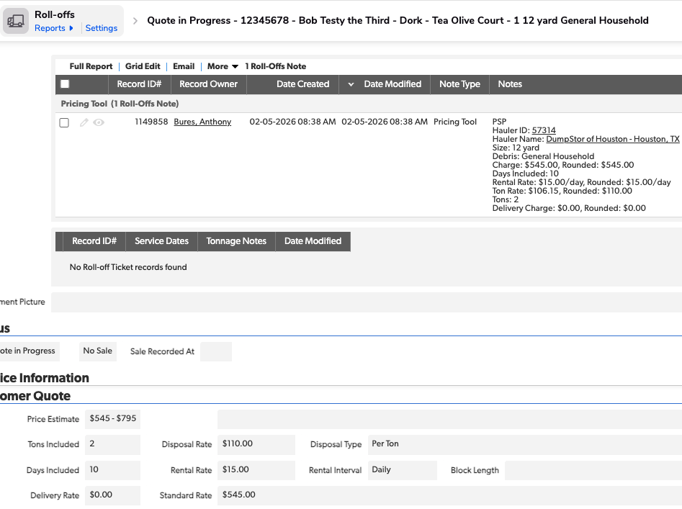
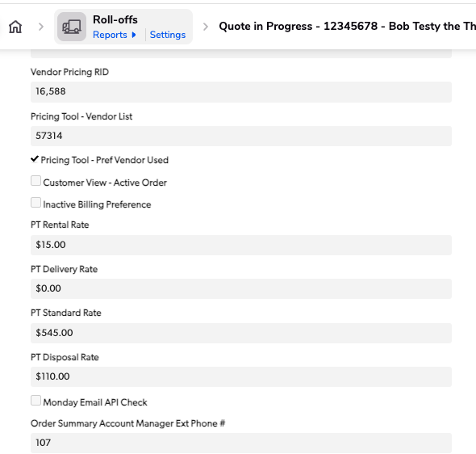

There is a Pricing Tool section in the Administrative tab. It displays the ID from the Vendor Pricing QuickBase, which, in this case, is record 16588.
https://zters.quickbase.com/nav/app/brd5gaz5n/table/breujw4za/action/dr?rid=16588&rl=vx3

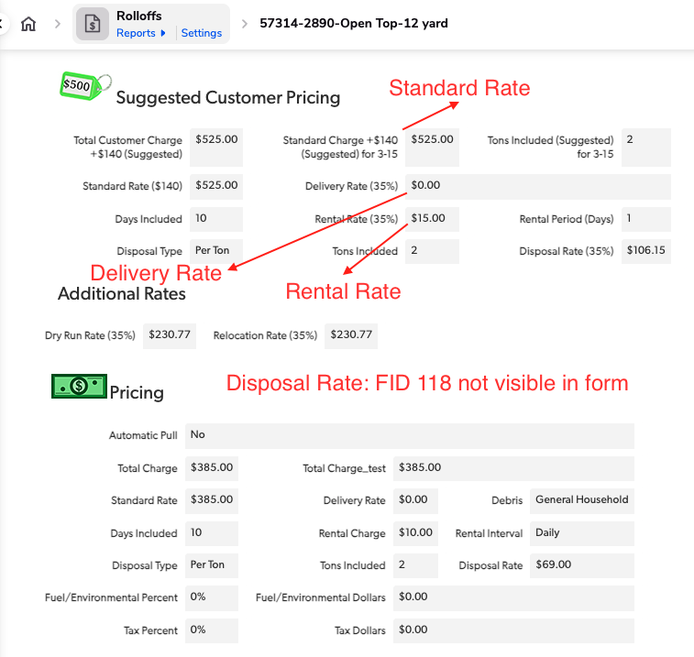

As you can see, the Standard Charge (+140, Suggested) for 3-15, the Delivery Rate (35%), Rental Rate (35%), and FID 118 (which is not visible in the form) are the same as the values displayed in the Pricing Tool in the Hub app—except for the Standard Charge. The values have a $20 increase due to the pricing adjustment process.

